**911675180**

Base URL:

**https://ikm.org.my/publications/malaysian-journal-of-chemistry**

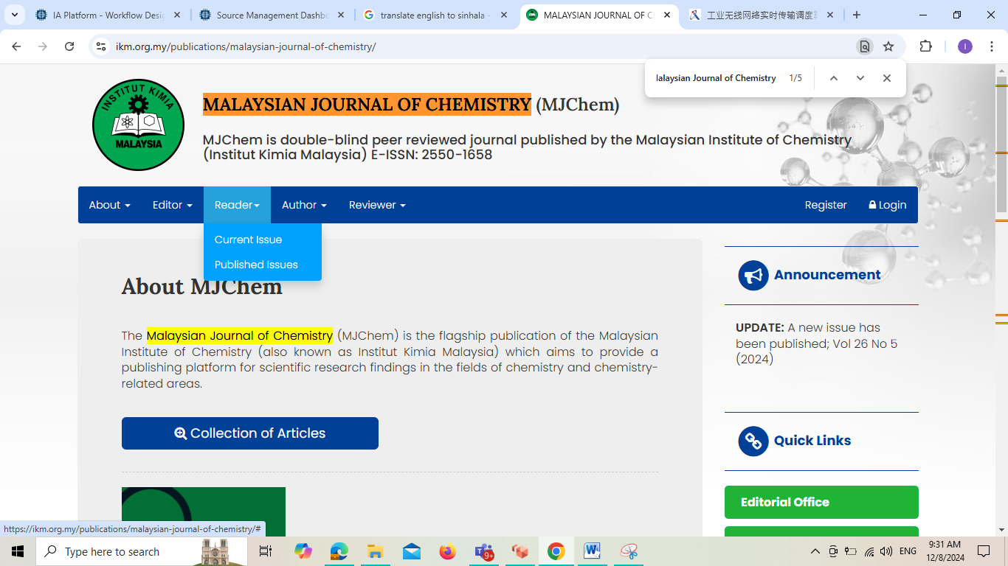

**Select the Current issue from here.**

* Meta data can be captured as below.

**Volume, Issue and Year**



**Page Range**

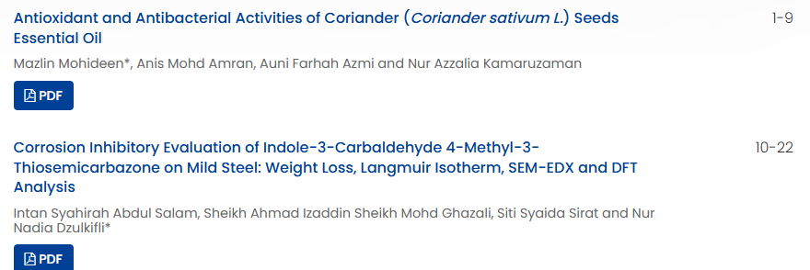

**Article Name**

**Page range**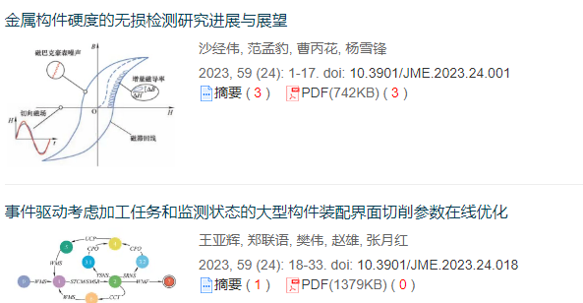

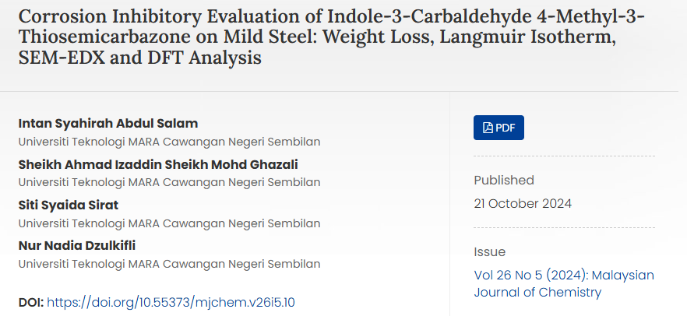

**Click here to download the pdf**

**DOI**